|  |  |  |  |
| --- | --- | --- | --- |
| Array Scoreboard | DoubleLinkedList | SingleLinked List | n |
| 1 | 2 | 1 | 100 |
| 4 | 2 | 2 | 1000 |
| 108 | 4 | 5 | 10000 |
| 2888 | 21 | 18 | 50000 |
| 18422 | 73 | 55 | 100000 |
| 1114931 | 131 | 172 | 500000 |

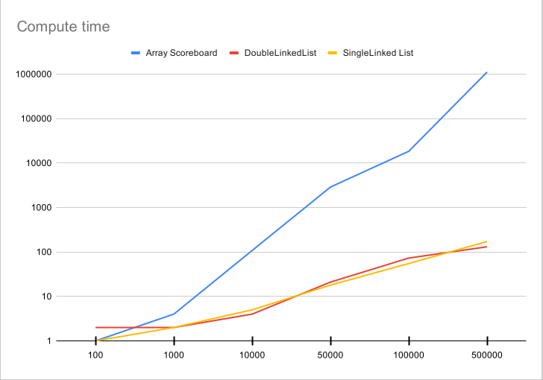

I think all three of the method we used for scoreboard creation have a order of O(n) since I only used one for loop to fill the scoreboard. I think the variation between the array and the linked lists processing time is a natural occurrence since arrays are more intensive to create and fill since in order to fill an array you must make room for the new entry. A linked list does not care about positions in memory since every entry is assigned a pointer.

Functions 1, 2, and 4: All three of these functions have a single loop which is the greatest O(n) value of the function.

Function 3: This function has a single nested loop which gives O(n*n) = O(n^2)

Function 4: This function has a double nested loop which gives O(n^3)